<https://learn.microsoft.com/en-us/fabric/get-started/fabric-terminology>

<https://learn.microsoft.com/en-us/fabric/enterprise/licenses>

Microsoft Fabric concepts - Microsoft Fabric

Understand Microsoft Fabric concepts such as tenants, capacities, and SKUs.

|  |  |  |
| --- | --- | --- |
| [aritra.basu@accenture.com](mailto:aritra.basu@accenture.com) | [AzureFabricUser5@acpcloud1896outlook.onmicrosoft.com](mailto:AzurePortalUser5@acpcloud1896outlook.onmicrosoft.com) | (Username) Accenture@123 |

(Joya456@Sai)

<https://app.fabric.microsoft.com/>

Power BI

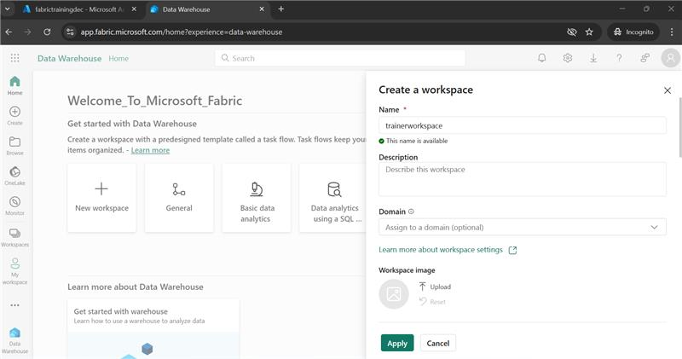

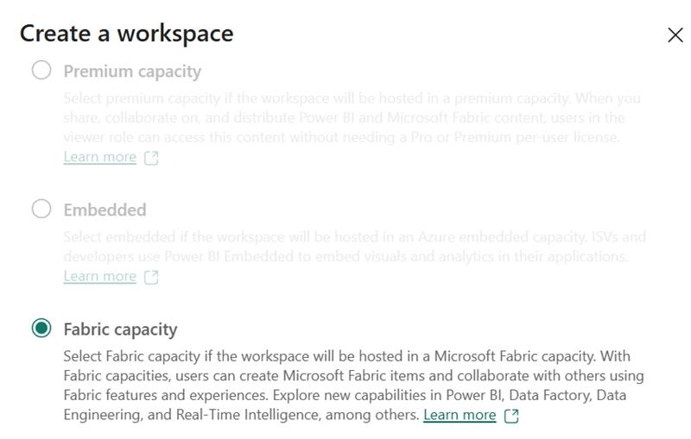

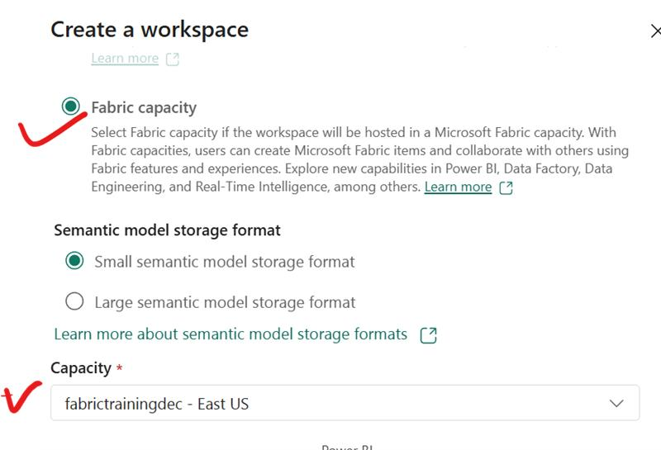

create workspace  
create lakehouse  
create subfolder --> upload the dataset (sfcalls)  
create notebook or import notebook save as (then you can edit)

copy the abfs path of your datset

1. start working on spark df and spark streaming  
2. delta table  
3. Multi- hop arch

image by Govindarajan, Mathan KumarGovindarajan, Mathan Kumar10:08 AM

has context menu

<https://learn.microsoft.com/en-us/fabric/onelake/onelake-medallion-lakehouse-architecture>

| **Module** | **Lab** |
| --- | --- |
| Get started with lakehouses in Microsoft Fabric | [Create a Microsoft Fabric Lakehouse](https://microsoftlearning.github.io/mslearn-fabric/Instructions/Labs/01-lakehouse.html) |
| Use Apache Spark to work with files in a lakehouse | [Analyze data with Apache Spark](https://microsoftlearning.github.io/mslearn-fabric/Instructions/Labs/02-analyze-spark.html) |
| Work with Delta Lake tables in Microsoft Fabric | [Use delta tables in Apache Spark](https://microsoftlearning.github.io/mslearn-fabric/Instructions/Labs/03-delta-lake.html) |
| Organize a Fabric lakehouse using medallion architecture design | [Create a medallion architecture in a Microsoft Fabric lakehouse](https://microsoftlearning.github.io/mslearn-fabric/Instructions/Labs/03b-medallion-lakehouse.html) |
| Use Data Factory pipelines in Microsoft Fabric | [Ingest data with a pipeline in Microsoft Fabric](https://microsoftlearning.github.io/mslearn-fabric/Instructions/Labs/04-ingest-pipeline.html) |
| Ingest Data with Dataflows Gen2 in Microsoft Fabric | [Create and use Dataflows (Gen2) in Microsoft Fabric](https://microsoftlearning.github.io/mslearn-fabric/Instructions/Labs/05-dataflows-gen2.html) |
| Get started with data warehouses in Microsoft Fabric | [Analyze data in a data warehouse](https://microsoftlearning.github.io/mslearn-fabric/Instructions/Labs/06-data-warehouse.html) |
| Load data into a warehouse in Microsoft Fabric | [Load data into a warehouse using T-SQL](https://microsoftlearning.github.io/mslearn-fabric/Instructions/Labs/06a-data-warehouse-load.html) |
| Query a data warehouse in Microsoft Fabric | [Query a data warehouse in Microsoft Fabric](https://microsoftlearning.github.io/mslearn-fabric/Instructions/Labs/06b-data-warehouse-query.html) |
| Monitor a data warehouse in Microsoft Fabric | [Monitor a data warehouse in Microsoft Fabric](https://microsoftlearning.github.io/mslearn-fabric/Instructions/Labs/06c-monitor-data-warehouse.html) |
| Secure a Microsoft Fabric data warehouse | [Secure a Microsoft Fabric data warehouse](https://microsoftlearning.github.io/mslearn-fabric/Instructions/Labs/06d-secure-data-warehouse.html) |
| Get started with Real-Time Intelligence in Microsoft Fabric | [Get started with Real-Time Intelligence in Microsoft Fabric](https://microsoftlearning.github.io/mslearn-fabric/Instructions/Labs/07-real-time-Intelligence.html) |

